Dalson's MAIA to Autocount integration

MAIA × AutoCount Integration Checklist
Dear Sir/Madam,
Hope you are doing well. I am reaching out on behalf of Dalson Industrial Supplies, as we are currently working together on a project to implement MAIA — an AI-powered operational assistant that will sit on top of AutoCount to help their team handle sales orders, invoicing, and document management more efficiently.
As part of this project, we will be integrating MAIA into Dalson's AutoCount environment (version 2.2, cloud-hosted). To proceed smoothly, we will need several items from your end. We have done our best to keep this list practical and specific — many of the generic items that would not apply to a standard AutoCount cloud setup have been removed.
We understand you are the system owner and the person who set up and maintains Dalson's AutoCount. We would appreciate your support in working through the items below. If any item is unclear or does not apply, please just let us know and we will clarify.

Note
All documents can be uploaded to the google drive link below
https://drive.google.com/drive/folders/1Dt6_E6k6eS6g4iGFays37G4PfFtBxDjL?usp=sharing

What we are building
MAIA will connect to AutoCount to:
- Read customer records (debtor maintenance) and item(SKU) master data
- Push confirmed sales orders and invoices into AutoCount
- Trigger e-invoice (LHDN) generation via AutoCount
- Reference pricing and stock data during order creation
AutoCount remains the accounting and invoicing core throughout. MAIA does not replace it.

What we need from you

1. Your contact details as system owner
So we can reach you directly when technical questions come up during integration and testing.
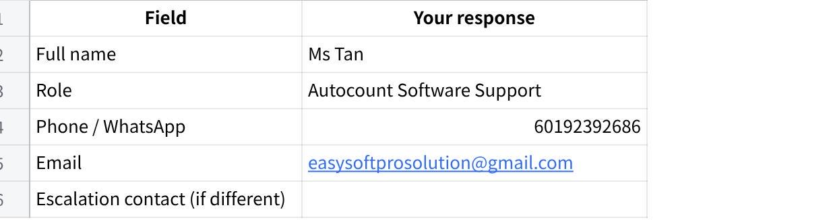
点击图片可查看完整电子表格

2. AutoCount system information
We already know Dalson is on AutoCount version 2.2 (cloud). Please confirm or correct the details below, and provide anything missing.
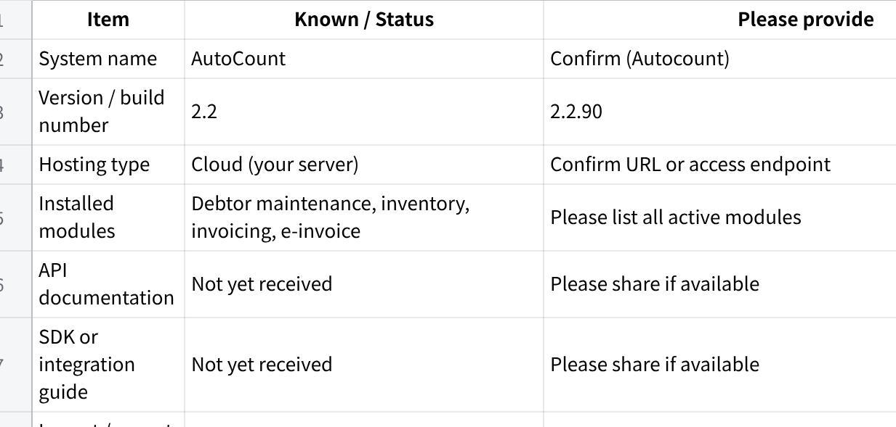
点击图片可查看完整电子表格

3. Staging or test environment
We prefer to test the integration in a staging or test environment before touching live data. This protects Dalson's production records during development.
- Do you have a staging / test environment available for Dalson's AutoCount?
- If yes — please confirm the data was cloned from live, and the date of the last refresh.
- If no — please advise your recommended approach for safe integration testing.

4. Remote or server access
Since Dalson's AutoCount is cloud-hosted on your server, we may need remote access to set up and test the integration middleware. Please advise:
- What remote access method is available? (e.g. RDP, SSH, AnyDesk, UltraViewer, web-based admin panel)
- Are there any restrictions on who can be given access?
- Is there an approval process or form to complete?
If the integration is fully API-based and no server-side deployment is needed, this section may not apply — we will confirm once we review the API documentation.

 | 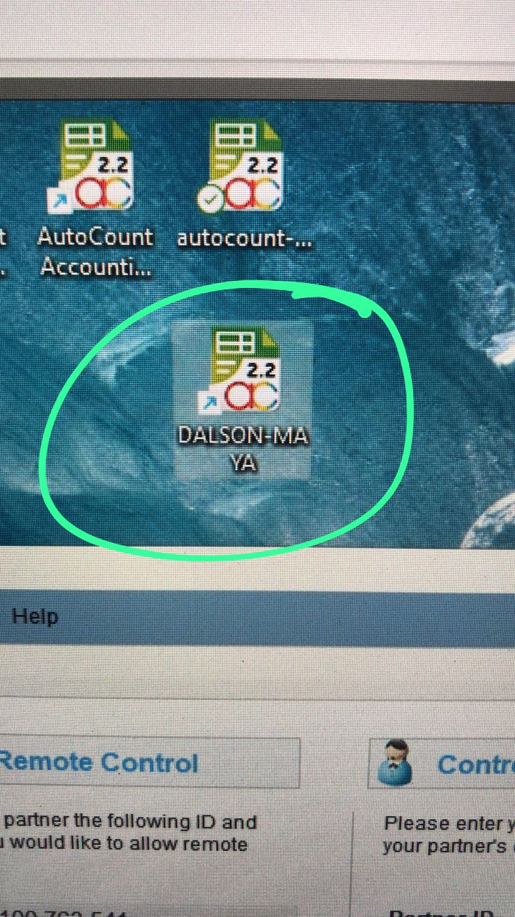
  Ultraviewer ID: 100 763 541
  pw: 03935
  Autocount ID: admin
  Pw: admin
  Windows ID: MAYA
  Pw: MAYA

5. Network, firewall, and IP whitelist requirements
For MAIA's servers to communicate with AutoCount, we may need certain IP addresses or ports to be whitelisted.
Please advise:
- Are there firewall rules or IP whitelist requirements we need to comply with?
- What ports are open for external API access?
- Is there a VPN requirement to access the AutoCount environment?
- How long does access approval take, and who approves it?

6. Middleware hosting (if required)
If any integration component needs to be installed on the server side (rather than hosted on MAIA's AWS infrastructure), please advise:
- Server location (physical or cloud)
- Operating system
- Whether internet access is available from the server
- Whether administrator rights can be granted to Mindhive
- Any startup or restart procedures we need to follow
- Any operational constraints (e.g. no restarts during business hours)
We will confirm whether server-side deployment is needed once we review the API approach.

7. Login and access credentials for integration testing
We will need a working account to validate data mappings and test transactions end-to-end. Please provide:
- AutoCount web login — URL and a test user account with sufficient permissions to view records and create transactions
- API user credentials — API token or key, authentication method, environment details (sandbox vs production)
- Read-only database access — if direct DB access is available and relevant
- Test user account — ideally with the same permission level as Dalson's sales coordinators
(Input details here)

8. Access timing and constraints
Please let us know if there are any restrictions on when Mindhive can access the system:
- Allowed support hours (e.g. weekdays only, 9am–6pm)
- Any blackout periods (e.g. month-end closing, audit periods)
- Maintenance windows
- Whether you or a member of your team needs to be present during testing sessions
(Input details here)

9. AutoCount client access confirmation
Before integration development begins, we would like to confirm that Mindhive can successfully:
- Log in to AutoCount
- View debtor (customer) records
- View item / inventory records
- View and create sales orders and invoices
- Perform basic test transactions without affecting live data
Please share the web application URL or local client setup guide so we can confirm access.

10. Customisation documentation
Dalson's AutoCount appears to be a standard installation with no major customisations. However, if any of the following have been added, please let us know:
- User-defined fields (UDF) on any module
- Custom tables or forms
- Custom approval workflows
- Custom report templates
- Any scripts, plugins, or third-party integrations already connected
Even minor customisations can affect how data is structured and how MAIA reads or writes records.

Any customization that falls outside Base MAIA features is considered out of scope for this project

Summary checklist
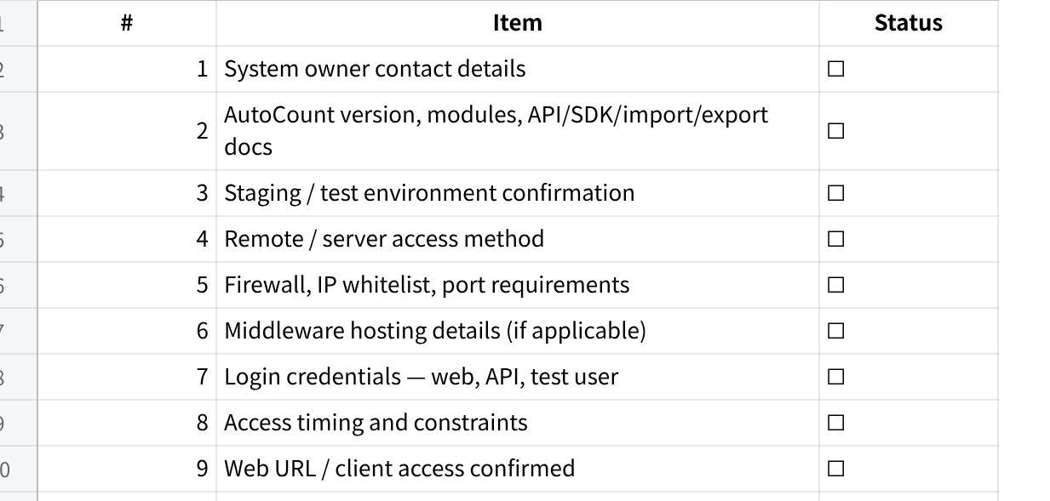
点击图片可查看完整电子表格
All documents can be uploaded to the google drive link below:
https://drive.google.com/drive/folders/1Dt6_E6k6eS6g4iGFays37G4PfFtBxDjL?usp=sharing

